Part 1 Assignment

Name

Course
Instructor
Location
Institution

Date

Introduction
The human body is made up of cells which build up to tissues, organs, organ system, and lastly the organism. The tissues work to ensure a standard functionality is achieved, and thus the body functions effectively. However, at the time the tissues are affected by infections either caused by pathogens or dysfunction of the body cells. This paper addresses the differences between anatomy and physiology, the differences between benign and malignant tumors, the skin and its relation to body functionality, the four types of cells, and diseases affecting the skin.
Question One
The difference between anatomy and physiology
According to Tortora & Derrickson (2017), anatomy is the concept that deals with the study of structure like muscles, bones, and other interior organs of the body. On the other hand, physiology deals with the study of functions of different organs like digestion, respiration, reproduction, and osmoregulation, and thus, the conditions are regarded as dynamic. The importance of anatomy is that it helps an individual to acknowledge the vital body parts while physiology helps us to understand the essential functions of every organ of the body (Tortora, & Derrickson, 2017). When anatomy students focus on studying the structure of the heart, its chambers, arteries, veins, and valves, physiology students focus on knowing how the heart pumps blood.
The differences between benign and malignant tumors.
According to Spanhol et al., (2015), a tumor is a mass of tissue that may resemble a swelling. Tumors are also a mass of tissues that result when cells divide more than they should, or others fail to die when they should. The common types of tumors affecting people’s cells are benign and malignant tumors and bear several differences. Benign tumors usually grow very slowly and are smaller in size (Spanhol et al., 2015). They may take many years to grow and develop. On the other hand, the malignant tumors grow faster, within a few weeks and a larger. The benign tumors are freely movable on the tissue they attach themselves to while the malignant tumors are challenging to move around because of local tissue invasion (Spanhol et al., 2015). The benign tumors have a slight resemblance to the tissues of origin, especially when viewed via naked eyes. The malignant tumors appear different from their tissues of origin. Benign tumors have little altered nucleoli, while the cancerous tumors have large nucleoli (Rouhi & Jafari, 2016).
Additionally, benign tumors are abnormal growths that occur on tissues and have no specified purpose. They are not cancerous and thus not harmful (Spanhol et al., 2015). They can cause pain if they trigger the overproduction of hormones as in the endocrine system. For example, the adenomas tumors are growing on glandular epithelial tissue and fibroids, which grow on connective tissues (Rouhi & Jafari, 2016). The malignant tumors are cancerous and grow uncontrollably, and thus, their continuous development makes them life-threatening (Spanhol et al., 2015). Via a process called metastasis, the malignant tumors grow and spread rapidly even to other cells different from the original ones. For example, the carcinoma tumors which grow from epithelial cells and are prevalent in the stomach, prostate, pancreases, or breasts, thereby causing cancer on those organs.

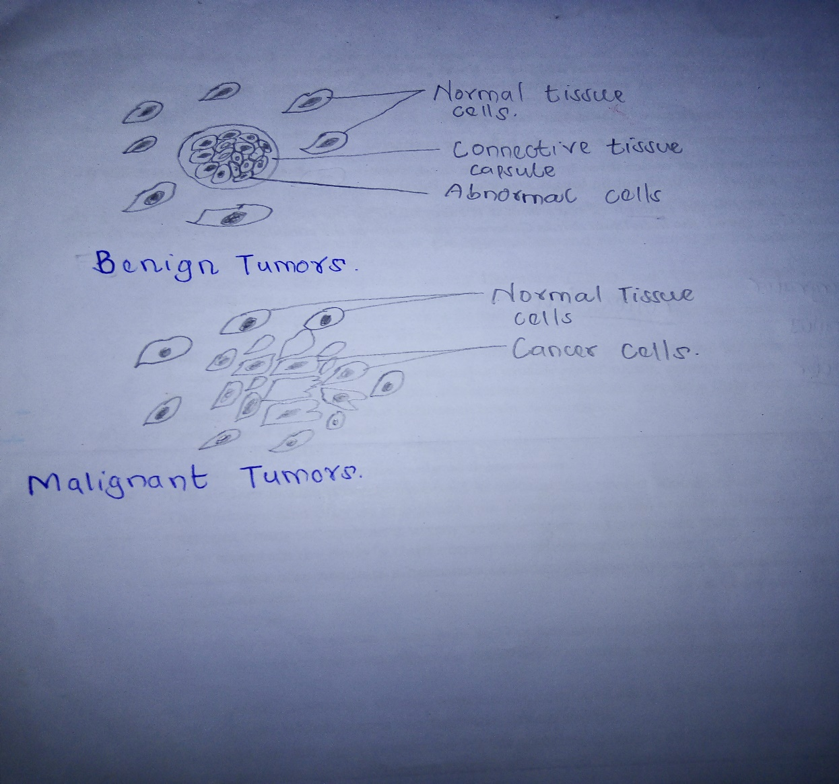
Fig 1.1: The image of benign and malignant tumors

Question Two
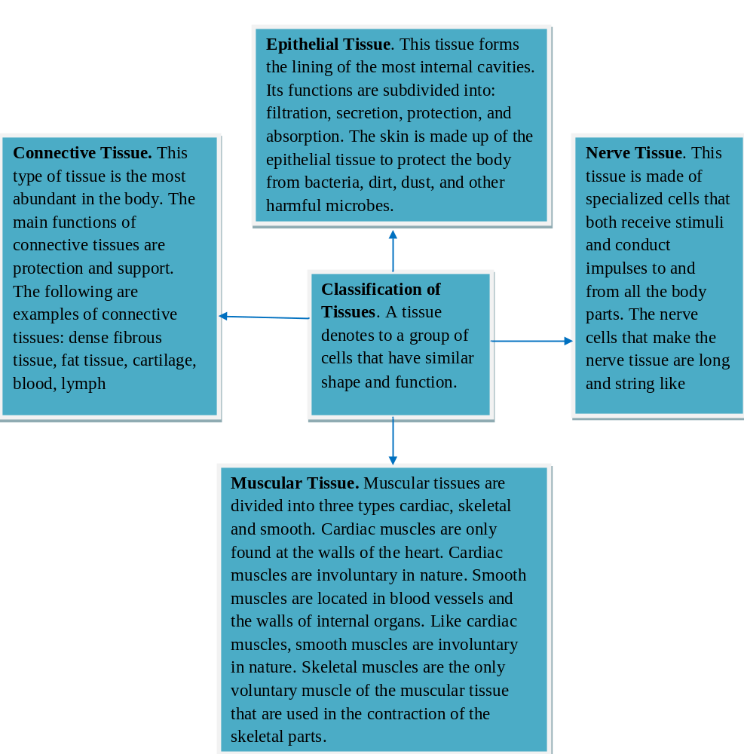
Fig 1.2: The illustration the four types of tissues (Cited from Research and Reviews Journal of Zoological Sciences , 101-107.
)

Question Three
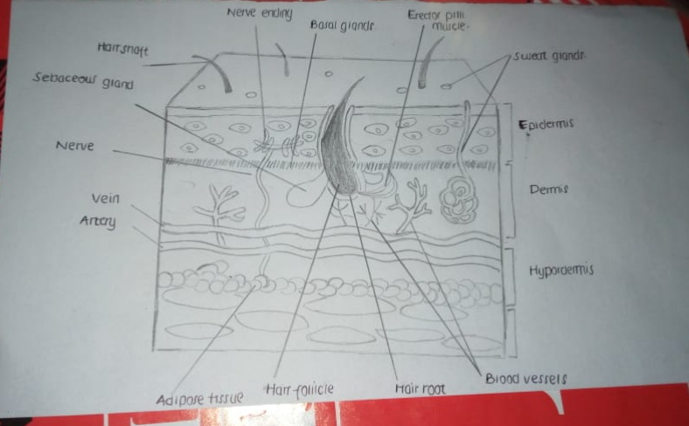
Fig 1.3: The human structure of skin
The skin is the largest organ of the body. It offers protection against the entry of microbes and mechanical injury of the underlying body tissues. It also regulates body temperature and permits sensational touch, heat, and cold. The skin has three layers; the epidermis is the outermost layer of the skin that provides a waterproof barrier and creates our tone (Misery, Loser, and Ständer, 2016). The dermis, beneath the epidermis, contains tough connective tissue, hair follicle, and sweat glands. The deeper subcutaneous tissue is made of fat and connective tissue. The subcutaneous tissue layer also functions to help keep the body temperatures stable. It also acts as a passageway for the nerve and blood vessels from the dermis to the muscle. Lastly, it helps in protecting the muscles from damage.
The sweat glands are found all over the body in the skin. The glands secrete sweat that is removed from the collection by moving up the sweat duct and is excreted via the sweat pore. Sweat is mainly water but also contains some salts and thus functions to control body temperature (Misery, Loser, and Ständer, 2016). The nerve endings sense pain, touch, pressure, and temperature. Some areas of the skin have more nerve endings than others like the toes, and fingertips have many nerve endings and thus extremely sensitive to touch (Misery, Loser, and Ständer, 2016). The sebaceous gland secretes sebum into hair follicles, which keeps the skin moist and soft and serves as a protective barrier against foreign substances. The hair follicle produces various types of hair found throughout the body. The hair helps in the regulation of body temperatures, protects from injury, and enhances sensation. More significantly, a portion of hair follicle bears stem cells capable of re-growing damaged epidermis. The dermis has blood vessels that supply nutrients to the skin and helps regulate body temperature.
Question Four
Relationship between the skin and the nervous system
The skin plays essential roles in the body regarding the sense of touch and thus is highly related to the nervous system. The nervous system depends on the nerves embedded in the skin to sense the changes happening from outside (Walløe, 2016). More significantly, the skin offers protection to the body's nerves. For example, when a person is pricked, the nerve cells underlying in the skin sense the pain and move the impulse to the central nervous system for interpretation (Walløe, 2016). This is either in the brain or on the spinal cord. Through the senses conducted from the skin, nerve cells serve as a source of important message on what should be done to restore the body into its normal conditions as well as relieve the body from any possible pain (Misery, Loser, and Ständer, 2016).
Relationship between the skin and circulatory system.
The circulatory system is mandated to transport nutrients, oxygen, and hormones to cells all over the body as well as the removal of metabolic wastes from the body. The relationship between the skin and circulatory system becomes evident since the skin has blood vessels that supply blood and nutrients to the skin cells (Walløe, 2016). Additionally, the blood vessels carry blood containing urea and other metabolic waste that is removed from the body in the form of sweat. The skin works together with the nervous system in the regulation of body temperatures (Walløe, 2016). During hot days, the blood vessels dilate, the hair lies down, and we sweat to allow excess heat to escape the body. In cold days, the blood vessels constrict, and thus, the hair stands erect and traps air molecules that insulate the skin against loss of heat. There will be no production of sweat during cold times.
Question Five
The skin is just like any other organ in the body in that it is prone to infections. The branch of medicine that deals with diagnosis, treatment, and prevention of skin diseases is called dermatology. Additionally, dermatology helps people to understand how they can apply cosmetics for effective cosmetic enhancement. There are many skin diseases, but this paper narrows down to dermatitis.
Dermatitis is an inflammation of the skin usually characterized by redness, swelling, blister formation, and oozing resulting from frequent itching. The types of dermatitis narrow down to four, which include; contact dermatitis, which is mainly caused by the contact of skin with an irritating substance, especially if the person is allergic. Additionally, some chemical contacts like nickel and chromium cause dermatitis. Avoidance of the causative substances is the best kind of prevention of this type of dermatitis.
Atopic dermatitis is the second type of dermatitis which prevalent in children, especially during infancy, but can still last until adulthood. This infection is characterized by redness, thickening, and scaling of the skin in patches common on the face, neck, and hands (Tsakok et al., 2016). The skin becomes dry, and results in continuous itching. Immune dysfunctions play a significant role in the occurrence of atopic dermatitis. Stasis dermatitis is a skin inflammation affecting the ankles and lower legs due to chronic blood flow in the veins, and precisely the varicose vein (Tsakok et al., 2016). The skin swells and thus resulting in ulcerations. Taking steps to improve the blood circulation of the legs serves as the best preventative measure for stasis dermatitis. Lastly, there is seborrheic dermatitis, which is a rough condition that most frequently affects the scalp and associated with dandruff. This infection is common in areas with numerous sebaceous glands and can touch the forehead, elbows, and behind the ears.
Environmental factors have a significant influence on skin infections. For instance, people who are exposed to omega-3 fatty acids at their infancy tend to have tough skin with little or no impacts of dermatitis (Tsakok et al., 2016). The progress of dermatitis depends on how well the patients are medicated, as well as the nutrition to provide the missing nutrients in the body. If the patient follows the effective medication, then dermatitis diminished. However, this depends on the stage at which the infection has been identified.
In England, dermatitis is in the increase affecting at least one out of every five children. This may be due to genetic conditions or lack of breastfeeding, which provides omega-3 fatty acids (Tsakok et al., 2016). Moreover, dermatitis is a prevalent condition affecting about 15-20 of the UK population. This skin disorder reduces the consistency of workers in executing their regular duties, especially during sunny days. Conducting effective clinical examinations is reported to be one of the successful strategies of eliminating dermatitis (Tsakok et al., 2016). In addition, there are protective measures like the use of cleansing products to cleanse the hands, especially when working with chemicals that may harm the skin.
Conclusion
In conclusion, this paper has addressed critical issues that reflect on human life. The study of tumors helps us to know how to identify the tumors. This briefs us on cancer-causing tumors, malignant tumors, and thus we can take appropriate action when the tumors start appearing. Additionally, understanding the different types of the cell helps in boosting our knowledge of our bodies. The skin is a vital organ that helps in the maintenance of body temperatures and receiving stimuli from the surrounding, which initiates appropriate actions. Lastly, there are skin diseases like dermatitis, which affect the normal functioning of the skin, and thus, people need to acknowledge how they can reduce the prevalence of dermatitis.

Bibliography
Misery, L., Loser, K. and Ständer, S., 2016. Sensitive skin. Journal of the European Academy of Dermatology and Venereology, 30, pp.2-8.
Rouhi, R., & Jafari, M. (2016). Classification of benign and malignant breast tumors based on hybrid level set segmentation. Expert Systems with Applications, 46, 45-59.
Spanhol, F.A., Oliveira, L.S., Petitjean, C. and Heutte, L., 2015. A dataset for breast cancer histopathological image classification. IEEE Transactions on Biomedical Engineering, 63(7), pp.1455-1462.
Tortora, G. J., & Derrickson, B. H. (2017). Introduction to the human body. John Wiley & Sons, Incorporated.
Swetha, R. (2016). Review on Animal Tissues. Research and Reviews Journal of Zoological Sciences , 101-107.
Tsakok, T., Marrs, T., Mohsin, M., Baron, S., du Toit, G., Till, S. and Flohr, C., 2016. Does atopic dermatitis cause food allergy? A systematic review. Journal of Allergy and Clinical Immunology, 137(4), pp.1071-1078.
Walløe, L., 2016. Arterio-venous anastomoses in the human skin and their role in temperature control. Temperature, 3(1), pp.92-103.

